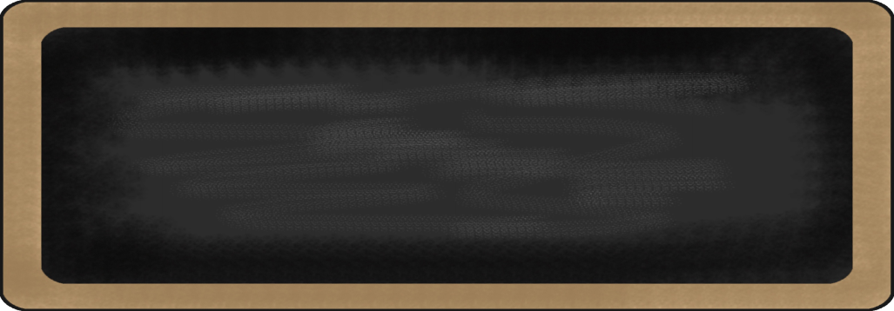

Vocabulary Words (Test Friday!)

1. Geology
2. Geographical
3. Geometry
4. Geothermal
5. Geography
6. Terracotta
7. Terrazzo
8. Terrarium
9. Terrafirma

10.Terrace

*Test will be this Friday. No spelling. Test will be put the word in the blank.*

Mrs. Bonham’s Bunch

July 15, 2013

MC900134537[1]

Auction

At the end of July, we will have our first monthly auction and bid with the “money” we have received through the month for classroom behavior and jobs. I am looking for donations from you to make this auction successful. See side box for ideas for auction.

|  |  |  |  |  |  |
| --- | --- | --- | --- | --- | --- |
| **reading** | **Writing** | **Word** | **Math** | **Science** | **Social studies** |
| * Summarize * Theme | * Imaginative Narrative | * “Geo” and “terra” | * Place Value | * MC900441708[1]Animals | * Map Skills * Three regions of NC |

MC900232760[1]

MC900290705[1]

MC900088530[1]

Possible auction items:

* New or slightly used books
* Gift Cards (restaurants, itunes, amazon, target, walmart, toys r us)
* Candy
* Donations from businesses
* Toys
* Cool pencils, markers or art supplies
* Flash Cards

We have had a great first week back! The students have been very respectful and have jumped right into the school routine.

If you have any questions, please feel free to email me at [lbonham@wcpss.net](mailto:lbonham@wcpss.net).

Don’t forget to check out the blog mrsbonhambunch.weebly.com

MC900089728[1]

MC900237619[1]

What We are learning this week:

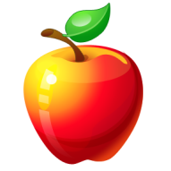

**Contact Information** :Laura Bonham (lbonham@wcpss.net)

www.mrsbonhambunch.weebly.com

